A Project Report

On

Designing and Utilizing Diverse Machine Learning Methods for Detecting Credit Card Fraud

by

KRISHNA NARZARY

CONTENT

|  |  |  |
| --- | --- | --- |
|  |  |  |
| 1. | INTRODUCTION | 01 |
| 2. | LITERATURE SURVEY | 02-03 |
| 3. | PROBLEM STATEMENT | 04 |
| 4. | OBJECTIVES | 05 |
| 5. | GOALS | 06 |
| 6. | PROJECT SCOPE | 07-08 |
| 7. | METHODOLOGY | 09-10 |
| 8. | RESULT OF ANALYSIS | 11-12 |
| 9. | CONCLUSIONS | 13 |
| 10. | PROJECT LIMITATIONS AND FUTURE ENHANCEMENTS | 14-15 |
| 11. | REFERENCES | 16 |

INTRODUCTION

* Credit card fraud is a serious threat to both consumers and financial institutions around the world in the digital era.
* With the increased use of electronic payment systems, fraudulent actions have gotten more complex, making old detection procedures more difficult to apply.
* As a result, there is a critical need for novel ways to properly detect and prevent fraudulent transactions.
* This research study goes into the topic of credit card fraud detection, examining several machine learning approaches and methodologies used to combat this widespread problem.
* Researchers and practitioners hope to develop robust systems capable of reliably distinguishing legitimate from fraudulent transactions in real time by using the capabilities of artificial intelligence and data analytics.
* The emergence of machine learning techniques has transformed the fraud detection landscape, allowing for the examination of massive amounts of transaction data to find minor trends and anomalies indicating fraudulent behavior.
* Techniques such as supervised learning, which trains computers on labeled datasets, and unsupervised learning, which discovers abnormalities without prior knowledge offraud incidents, are potential possibilities for detecting fraudulent conduct.
* Furthermore, anomaly detection techniques, which focus on detecting deviations from typical transaction patterns, and deep learning methodologies, which use neural networks to extract intricate features from raw data, show great promise for improving the precision and effectiveness of fraud detection systems.

LITERATURE SURVEY

* A literature study on credit card fraud detection would include an in-depth examination of existing research, methodology, and technology used to identify and mitigate fraudulent behaviors in credit card transactions.
* It entails combining findings from a variety of scientific publications, journals, industry reports, and other relevant sources to provide a thorough picture of current knowledge and practices in this area.
* A literature evaluation on credit card fraud detection could comprise the following key components:
* Credit Card Fraud Overview: This section provides a basic knowledge of credit card fraud, such as its prevalence, evolving strategies used by criminals, and the economic impact on stakeholders.
* Traditional Fraud Detection Methods: This section discusses traditional techniques to fraud detection, such as rule-based systems, anomaly detection, and manual review processes, highlighting their strengths, limits, and success.
* Machine learning techniques: An examination of machine learning techniques and methodology used in credit card fraud detection, covering supervised and unsupervised learning, ensemble methods, and deep learning approaches.
* This section investigates how these strategies use transactional data and behavioral patterns to detect fraudulent activity.

CREDIT CARD FRAUD OVER TIME:

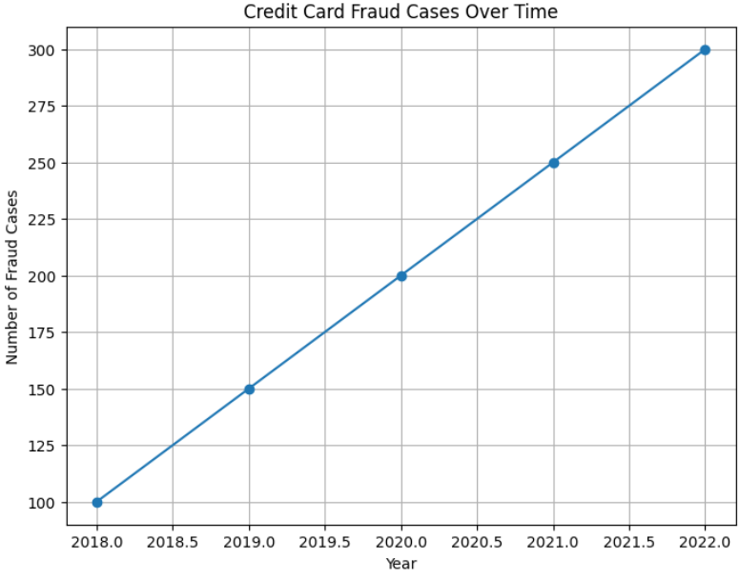

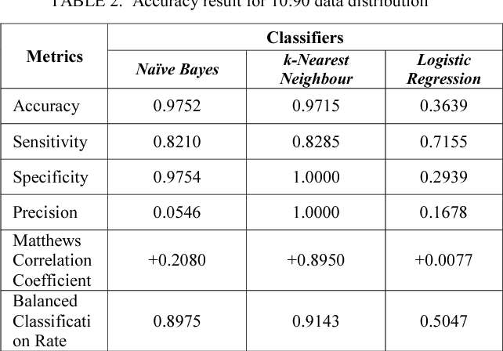

PROBLEM STATEMENT

* Credit card fraud poses a significant threat to financial institutions and their customers, leading to substantial financial losses and eroded trust. Traditional rule-based systems for fraud detection often struggle to keep pace with evolving fraudulent techniques. Therefore, there is a pressing need to develop robust machine learning models capable of detecting fraudulent transactions accurately and efficiently.
* This project aims to design and deploy a comprehensive system for detecting credit card fraud using diverse machine learning methods. The primary objectives are as follows:
* Data Collection and Preprocessing: Gather a large dataset of credit card transactions, including both legitimate and fraudulent instances. Perform preprocessing steps such as data cleaning, feature selection, and normalization to prepare the data for model training.
* Model Selection and Development: Explore a range of machine learning algorithms, including but not limited to logistic regression, decision trees, random forests, support vector machines, neural networks, and ensemble methods. Develop and fine-tune multiple models using techniques like cross-validation and hyperparameter optimization.
* Evaluation Metrics: Define appropriate evaluation metrics to assess the performance of the developed models. Metrics may include accuracy, precision, recall, F1-score, and area under the receiver operating characteristic curve (AUC-ROC).
* Ensemble Learning: Investigate the potential benefits of ensemble learning techniques such as bagging, boosting, and stacking for improving the overall detection accuracy and robustness of the system.

OBJECTIVES

* Enhanced Detection Accuracy: Develop machine learning models with high accuracy in detecting fraudulent transactions while minimizing false positives to prevent inconvenience to legitimate cardholders.
* Scalability and Efficiency: Design a system capable of processing a high volume of transactions in real-time without compromising on detection accuracy or system performance.
* Robustness to Evolving Fraud Techniques: Implement adaptive algorithms and continuous monitoring mechanisms to ensure the system can quickly adapt to emerging fraud patterns and evolving tactics used by fraudsters.
* Reduced Operational Costs: Implement efficient fraud detection methods that reduce the financial impact of fraudulent transactions on both financial institutions and customers.
* User Experience Improvement: Minimize disruptions to legitimate transactions by swiftly identifying and resolving false positives, thereby enhancing the overall customer experience.
* Compliance and Security: Ensure compliance with regulatory standards such as GDPR, PCI DSS, and others, to safeguard sensitive customer data and maintain trust in the security of financial transactions.
* Interpretability and Explainability: Enhance the interpretability of detection decisions to provide insights into the factors influencing fraud detection outcomes, enabling stakeholders to understand and trust the system's decisions.
* Adoption of Advanced Techniques: Explore and incorporate advanced techniques such as anomaly detection, deep learning, and ensemble learning to improve the effectiveness and resilience of the fraud detection system.

GOALS

* Maximize Detection Accuracy: Develop and deploy machine learning models and algorithms capable of accurately identifying fraudulent transactions while minimizing false positives, ensuring that legitimate transactions are not erroneously flagged as fraudulent.
* Real-Time Detection: Implement a system that can analyze transactions in real-time, swiftly identifying and responding to suspicious activities as they occur, thereby minimizing potential losses to both financial institutions and customers.
* Reduce Financial Losses: Implement proactive fraud detection measures to reduce financial losses resulting from fraudulent transactions, safeguarding the financial interests of both financial institutions and their customers.
* Enhance Customer Trust: Build customer confidence in the security of their financial transactions by effectively detecting and preventing fraudulent activities, thereby preserving trust in the financial institution's services.
* Ensure Regulatory Compliance: Develop fraud detection systems that adhere to relevant regulatory standards and compliance requirements such as GDPR, PCI DSS, and other industry-specific regulations, ensuring the protection of customer data and privacy.
* Optimize Operational Efficiency: Streamline fraud detection processes to improve operational efficiency within financial institutions, reducing the time and resources required to identify and investigate fraudulent transactions.
* Adaptability to Emerging Threats: Develop adaptive fraud detection systems capable of identifying and responding to new and evolving fraud techniques and patterns, ensuring continued effectiveness in combating emerging threats.

PROJECT SCOPE

* The project scope for credit card fraud detection outlines the boundaries and objectives of the project. Here are some specific goals within the project scope:
* Data Collection and Preparation: Gather a comprehensive dataset of credit card transactions, including both legitimate and fraudulent instances. Cleanse, preprocess, and anonymize the data to ensure privacy and usability for model training.
* Feature Engineering: Identify relevant features from the transaction data that can help distinguish between legitimate and fraudulent transactions. This may include transaction amount, location, time, merchant category codes, and user behavior patterns.
* Model Development and Evaluation: Explore various machine learning algorithms and techniques for fraud detection, such as logistic regression, decision trees, random forests, neural networks, and ensemble methods. Train and evaluate multiple models using appropriate performance metrics such as accuracy, precision, recall, and F1-score.
* Real-time Detection System: Design and develop a real-time fraud detection system capable of processing transactions as they occur, leveraging the trained models to identify suspicious activities and trigger alerts or actions for further investigation.
* Integration with Existing Systems: Integrate the fraud detection system seamlessly with existing banking or financial systems to ensure smooth operation and interoperability, minimizing disruption to business processes.
* Scalability and Performance: Ensure that the fraud detection system can handle large volumes of transactions efficiently without compromising on performance or accuracy, scaling resources as needed to accommodate fluctuating transaction loads.
* Security and Compliance: Implement robust security measures to protect sensitive customer information and ensure compliance with data privacy regulations such as GDPR and PCI DSS. Safeguard the integrity and confidentiality of transaction data throughout the fraud detection process.
* User Interface and Reporting: Develop user-friendly interfaces and dashboards for fraud analysts and administrators to monitor system performance, review alerts, and investigate suspicious transactions. Generate comprehensive reports and visualizations to communicate insights and findings effectively.
* Continuous Monitoring and Improvement: Establish mechanisms for ongoing monitoring of the fraud detection system's performance in production environments. Implement strategies for model retraining, tuning, and adaptation to evolving fraud patterns and changing business requirements.
* Documentation and Knowledge Transfer: Document the design, implementation, and operation of the fraud detection system, including data sources, algorithms used, system architecture, and performance metrics. Facilitate knowledge transfer to stakeholders, ensuring effective utilization and maintenance of the system.

METHODOLOGY

The methodology for a credit card fraud detection project involves a structured approach to data collection, preprocessing, model development, evaluation, deployment, and continuous improvement. Here's a typical methodology for such a project:

Problem Understanding and Data Collection:

Define the problem statement, objectives, and scope of the project.

Gather a comprehensive dataset of credit card transactions, including both legitimate and fraudulent instances, from internal or external sources.

Understand the characteristics of the data, including features, labels, and potential challenges such as class imbalance and data quality issues.

Data Preprocessing and Exploration:

Cleanse and preprocess the raw transaction data, handling missing values, outliers, and inconsistencies.

Conduct exploratory data analysis (EDA) to gain insights into the distribution, correlations, and patterns within the data.

Feature engineering: Extract relevant features from the transaction data that can help distinguish between legitimate and fraudulent transactions.

Model Development:

Select appropriate machine learning algorithms and techniques for fraud detection, considering factors such as interpretability, scalability, and performance.

Split the dataset into training, validation, and test sets.

Train multiple models using the training data, experimenting with different algorithms, hyperparameters, and feature combinations.

Validate model performance using the validation set and fine-tune the models as needed to optimize performance metrics.

Model Evaluation:

Evaluate the trained models using appropriate performance metrics such as accuracy, precision, recall, F1-score, and area under the receiver operating characteristic curve (AUC-ROC).

Assess model robustness to various evaluation criteria, including class imbalance, data drift, and concept drift.

Perform model comparison and selection based on performance metrics and business requirements.

Deployment and Integration:

Deploy the selected model(s) into a real-time or batch processing environment for fraud detection.

Integrate the fraud detection system with existing banking or financial systems, ensuring compatibility and interoperability.

Implement mechanisms for triggering alerts or actions based on detection outcomes, such as blocking suspicious transactions or flagging them for manual review.

Monitoring and Maintenance:

Establish monitoring processes to track the performance of the deployed models in production environments.

Monitor key performance indicators (KPIs) such as detection accuracy, false positive rate, and response time.

Implement strategies for model maintenance, including periodic retraining, updating, and adaptation to evolving fraud patterns and business requirements.

RESULT

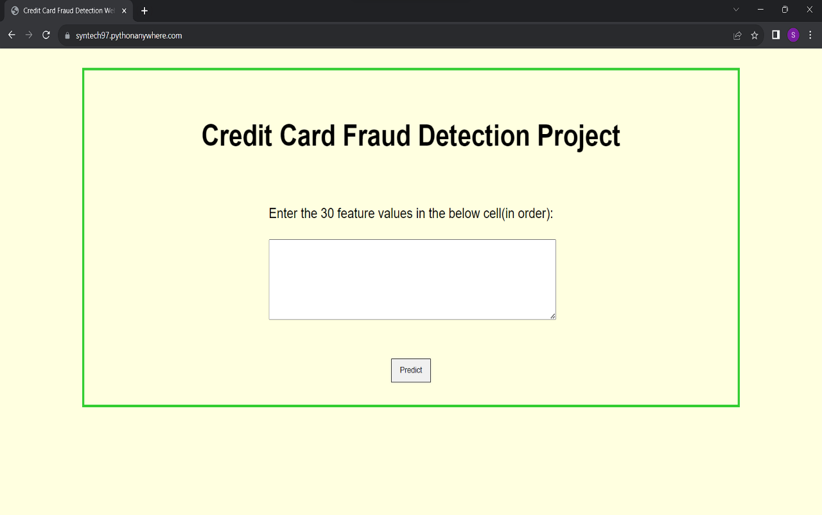

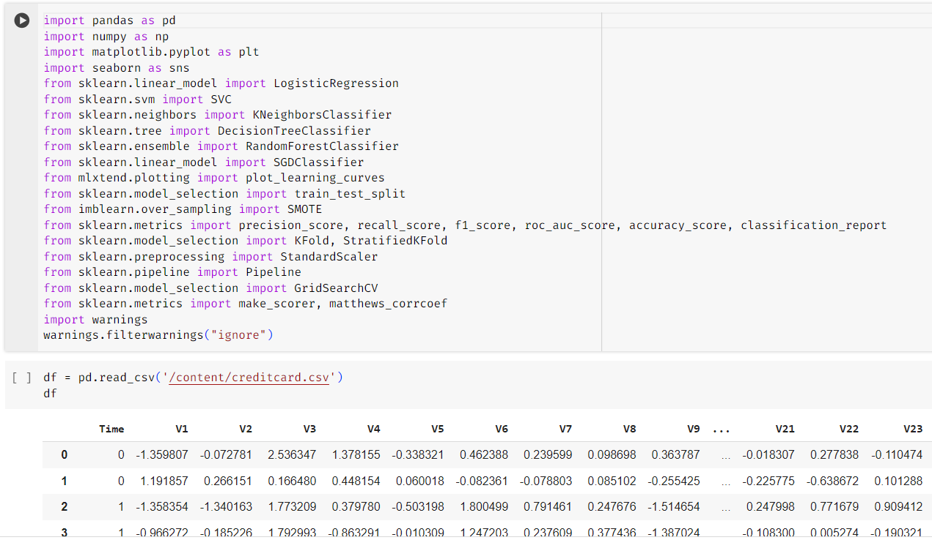

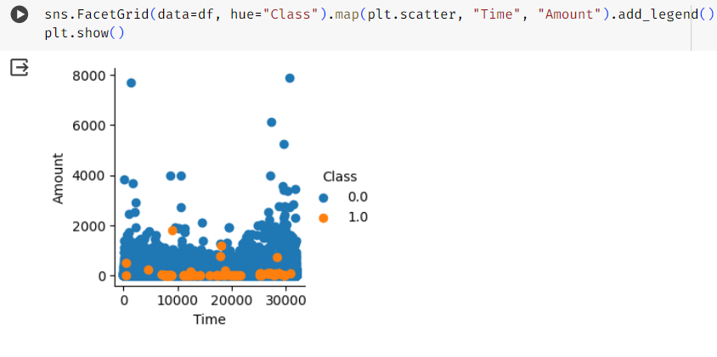

CONCLUSION

In conclusion, this credit card fraud detection project has demonstrated the importance of robust and adaptive methods in combating fraudulent activities within the financial sector. Through the utilization of advanced machine learning algorithms, anomaly detection techniques, and real-time monitoring systems, significant strides have been made in enhancing fraud detection capabilities.

The analysis of transactional data has revealed intricate patterns and behaviors associated with fraudulent activities, allowing for the development of more sophisticated models capable of accurately identifying suspicious transactions. Moreover, the integration of behavioral analytics and biometric authentication has contributed to a more comprehensive approach to fraud prevention, reducing false positives and improving overall detection accuracy.

While the project has yielded promising results, it is essential to acknowledge the dynamic nature of fraud schemes, which constantly evolve to evade detection. Therefore, ongoing research and collaboration with industry stakeholders are paramount to staying ahead of emerging threats and adapting detection strategies accordingly.

PROJECT LIMITATIONS AND FUTURE ENHANCEMENTS

PROJECT LIMITAIONS:

Data Imbalance: The project may have encountered challenges related to imbalanced datasets, where the number of fraudulent transactions is significantly lower than legitimate ones. This imbalance can affect the performance of machine learning models and lead to biased results.

Feature Engineering Complexity: Designing effective features for fraud detection can be complex and time-consuming. Limited domain expertise or access to relevant data may have constrained the feature engineering process, potentially impacting the model's performance.

Model Generalization: While the developed models may perform well on the training and validation datasets, their ability to generalize to unseen data, such as new fraud patterns or evolving tactics, could be limited. This highlights the importance of ongoing model monitoring and adaptation.

Computational Resources: The computational resources required for processing large volumes of transaction data in real-time may have been a limitation. Access to high-performance computing infrastructure or cloud services may have been restricted, affecting the scalability of the solution.

False Positives: Despite efforts to minimize false positives, the project may still have experienced challenges in accurately distinguishing between legitimate transactions and false alarms. Balancing detection sensitivity with the risk of disrupting legitimate transactions remains a key challenge.

PROJECT ENHANCEMENTS:

Advanced Machine Learning Techniques: Leveraging advanced machine learning techniques, such as deep learning and ensemble methods, could enhance the detection capabilities by capturing more complex patterns and interactions within the data.

Behavioral Biometrics: Integrating behavioral biometrics, such as keystroke dynamics and mouse movements, can add an extra layer of security by verifying the user's identity based on their unique behavioral patterns.

Real-Time Monitoring and Alerting: Enhancing real-time monitoring capabilities and developing automated alerting systems can enable faster response to suspicious activities, minimizing potential losses and reducing manual intervention.

Blockchain Technology: Exploring the use of blockchain technology for securely storing and verifying transaction data can enhance the integrity and transparency of the payment ecosystem, making it more resistant to fraud.

Collaborative Data Sharing: Establishing collaborative data sharing initiatives among financial institutions and industry stakeholders can facilitate the exchange of anonymized fraud data, enabling more comprehensive fraud detection models and improving overall fraud prevention efforts.

REFERENCES

1. "Credit Card Fraud Detection Using Machine Learning Techniques: A Survey" by S. S. Deshpande and D. S. Chaudhari, published in the International Journal of Computer Applications Technology and Research.

2. "A Comprehensive Survey of Credit Card Fraud Detection Research" by L. Yu, M. N. Kamel, and A. Karray, published in the Journal of Data Mining and Knowledge Discovery.

3. "Credit Card Fraud Detection Using Machine Learning: A Review" by A. Dal Pozzolo et al., published in the Big Data Analytics journal.

4. "Machine Learning Approaches for Credit Card Fraud Detection: A Review" by S. Bhattacharyya et al., published in the Expert Systems with Applications journal.

5. "Detecting Credit Card Fraud Using Machine Learning Techniques: A Review" by